

Department of Information Engineering and Computer Science

Bachelor’s Degree in
Software engineering

final dissertation

Autonomous Quadcopter Flight

Supervisor  Prof./Dott. Luigi Palopoli | Student  Massimo Girardelli

Academic year 2019/2020

INDEX

1 Hardware 5
1.1 Holybro X500 V2 Development Kit 5
1.2 5000 mAh Li-Po batteries 6
1.3 ROCK 4 C+ (Companion) 6
1.4 Commander computer 6
1.5 OptiTrack 6
2 Software 7
2.1 System 7
2.1.1 Ubuntu 22 7
2.1.2 Docker 7
2.1.3 ROS2 Humble 7
2.1.4 Python 3.10.12 8
2.1.5 PX4 8
2.2 Companion 9
2.3 Commander 9
2.3.1 px4-py.py 9
2.3.2 gui.py 10
2.4 Tracking 11
2.4.1 Motive 12
2.4.2 optitrack_interface 12
2.4.3 opti-to-px4.py 12
3 Simulation 13
3.1 Gazebo 13
3.2 RVIZ 14
4 Flying 15

- Abstract

This thesis is the design and development of a software application for controlling quadcopters and other flying drones.
Quadcopters have gained more attention in the past years due to their versatility and potential in various fields, including surveillance, aerial photography and transportation.
Although ready to use solutions and similar open source projects exist, an easily configurable, with a graphical interface and indoor capabilities that responds to external inputs doesn’t and this project aims to provide a working example of all these features that can be customized for different applications.
The project was developed around the ROS2 middleware and PX4 flight control software and can work in conjunction with other robots that support either of those platforms and in a modular fashion, where each component can be substituted with a similar one and expanded seamingless.
The final result is a working flying autonomous drone that can be interfaced both via software directly or through a graphical interface to perform various tasks like taking off, landing in a specific location, orbiting around a point, following a path, or be controlled manually from the pc.

Acronyms, Abbreviations and important terms

- PX4 | - PX4 is the Professional Autopilot. Developed by world-class developers from industry and academia, and supported by an active world wide community, it powers all kinds of vehicles from racing and cargo drones through to ground vehicles and submersibles.
- ROS2 | - robot Operating System version 2, middleware that enables fast and easy messages communications between different nodes on a network
- NED | - North-East-Down coordinate system where the X-axis is pointing towards the true North, the Y-axis is pointing East and the Z-axis is pointing Down, completing the right-hand rule.
- FRD | - Front-Right-Dwon coordinate system where the X-axis is pointing towards the Front of the vehicle, the Y-axis is pointing Right and the Z-axis is pointing Down, completing the right-hand rule.
- ENU | - xEast-yNorth-zUP coordinate system, the classic Cartesian coordinate system
- FLU | - Xfront-yLeft-zUp coordinate system,
- SITL | - Software in the Loop, a simulation tool that reproduces the flight controller behavior
- LTS | - “Long Term Support”, an LTS version of software recives supports for many years to come and thus is more preferred for compatibility
- GUI | - Graphical User Interface
- OptiTrack | - Motion capture system, used to detect the drone position with a tracker
- Commander | - Main computer from where the drone is controlled
- Companion | - Single board computer mounted on the drone

1 Hardware
This is the list of components used and some reasons behind the choices that were made.
This hardware can be swapped with other alternatives, depending on the availability of the components.

1.1 Holybro X500 V2 Development Kit
Main frame of the drone, it’s a good all-in-one solution for a quadcopter, it mounts 4 920 Kv motors, perfect for this application, lower Kv motors offer more torque and less fan speed, which is desired in this application give the weight of the whole system, a higher Kv motor would strugle more.
The Pixhawk 6C flight controller offers the right connectivity that we need for this esoteric application and easily provides the CPU and RAM taht we need.

1.2 5000 mAh Li-Po batteries
- A massive 5000 mAh Li-Po battery powers the motors, the flight controller and the companion computer.
- The 4S configuration offers 14.8V, when charged it can reach 16.8V, the drone will strugle to lift below 14V.
The exact model used is: “Dinogy Ultra Graphene 4S 5000mAh 80C”

1.3 ROCK 4 C+ (Companion)
A single board computer, similar to a Raspberry PI but with a 64-bit architecture.It’s a hexacore ARM processor with 4GB of LPDDR4 RAM, which is plenty for our needs.
The GPIO PINS are used for serial communication with the flight controllerConnection is done with Wifi and a SSH shell, power is delivered via USB.
The main issue with this board is the connectivity, like many other single board computers, a big part of the I/O is connected througha shared bus and this lowers the overall throughput of data; for this particular application the network connectivity was consistently low with random spikes in latency.
The problem was not the wifi module itself because alternatives adapters and ethernet cables were used and the underlying problem was still present.
In the end the limited networking was a compromise that caued trubles in developement but the final result is almost unaffected since the system is designed to operate at a slow speed and even 100ms of delay in time the system was stable.
  - Another problem was the old operating system: the company behind this board only supported version of Ubuntu up to the version 20.04, to keep this project up to date a Docker container was used to run Ubuntu 22 and ROS2 Humble.

1.4 Commander computer
- Any computer that can run the commander programs, preferably linux with Ubuntu 22 (reasons at Chapter 2.1), alternatively a computer that can run Docker. It’s possible to use the Companion itself but there are no guarantees of recovering the system in case of disconnection.

1.5 OptiTrack
- D Motion Capture Systems mounted in the laboratory, the precision is <1 cm, latency is around 30ms, publish rate is 360Hz by default but the drone remains stable up to 50 Hz of data recieved in case of network congestion.
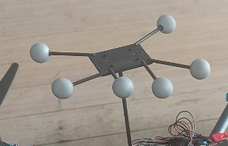Figure 1: tracking marker on top of the drone
- Tracking is done by recognition of a special tracking marker placed on the drone, each model saved has it’s own ID that will be transimmed with the data.
- The 9 cameras placed around the flying area, provide an accurate position estimation. The position is sent through the network and must be decoded by a client.
- This system is heavily dependent on a proper configuration of the cameras and a correct model of the tracking marker.

2 Software
- In this software chapter I will explain the systems and tools used to bring this project to life and the inner workings of the components to kae the drone fly.

2.1 System
- In this section I will focus on the operating system and system-wide software used, every other program suns on top of these:

2.1.1 Ubuntu 22
- This was a very important decision since every distribution of Ubuntu has it’s own ROS2 distribution and the latest LTS (for now) only supports Ubuntu 22.
- It’s possible to run ROS2 Humble on other distributions but it must be compiled from source and the chance of error gets bigger, expecially on embedded systems.
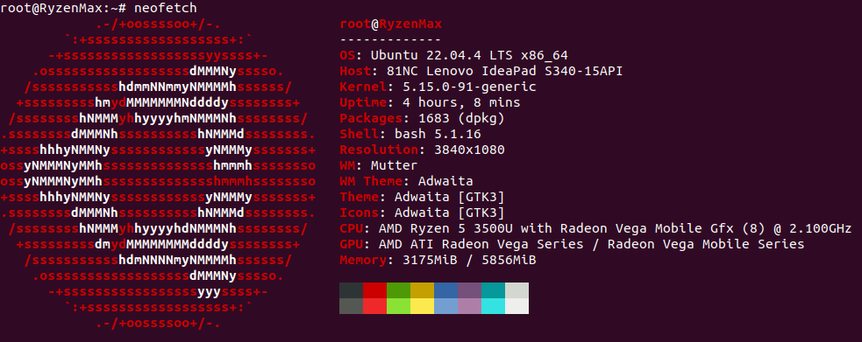Figure 2: Commander pc specifications

2.1.2 Docker
Docker is an amazing tool for virtualization and portability; with docker it’s possible to create an image of a system and run a container almost like a virtual machine.
The container has all the libraries needed to run an entire system and is widely used for compatibility since it’s possible to run a completely different operating system inside a container.
If it’s impossible to use or install Ubuntu 22 a good alternative is a docker container, like it was used for this project.

2.1.3 ROS2 Humble
Middleware used to share all messages between applications and to launch most of the applications, ROS resolves around Nodes, Topics and Messages:
- Nodes: a process interfacing with the ROS libraries, different nodes can run on different machines while being connected through networking and be visible to each other.
- Topics: a pipe-like virtual structure within ROS that can be used to share messages between different nodes, it can be interfaced as a publisher or as a subscriber, each topic routes one specific message type.
- Messages: data structures that travel through the nodes, it is not system-dependent and provides primitive types like booleans, integers, floats, arrays and nested messages types.
Custom messages were built for this projec

The optimal QoS (Quality of service) options were used:
- Best effort, to reduce network congestion, most messages are ephemeral and gets overriden a few milliseconds later, therefore if some messages are dropped it doesn’t affect the system
- Transient local: the publisher is responsible for delivering the last message tho subscribers who joined after it was published
- Keep last: only keeps the last message, previous values are invalid anyway

2.1.4 Python 3.10.12
Python was used for the ease of development and speed of deployment as it doesn’t need compilation; python with PX4 has also much more documentation and examples than any other language.
- Other programming languages that have better performance like c++ were considered but discarded due to minimal documentation, much more developing time and a very slow overall development experience and unpleasant experience:
- • ROS2 compilations have massive overheads, even for well written cmake and headers files while python has none;
- • a part of the code runs on the companion computer that, while powerful, is not really suited for continuos compilations
- (installing all the PX4 dependencies and building the optitrack package took more that 1 hour and a half)
- The runtime overhead of python gets completely eclipsed by the network delay.
The version 3.10.12 is the officially supported by ROS2 Humble.

2.1.5 PX4
Open source flight control solution for drones.
- ROS is used by PX4 to provide an offboard control functionality, with a linux companion computer. In this way its possible to control the PX4 flight stack using a software outside of the autopilot. PX4 supports both versions of the robotic operating system, but while the communication between ROS2 and the autopilot is done through a ROS2-PX4 bridge (MicroXRCEAgent).
- There are 2 ways to connect and read messages: ROS2-PX4 bridge or MavLink
- MavLik has a sligh different notation and needs it own libraries and messages while the ROS2-PX4 bridge only requires sourcing the message (done automatically when sourcing the whole ROS enviroment).
The custom PX4 messages are used by most of the software used.

2.2 Companion
The companion is a single board computer mounted on the drone, it’s role is to run the MicroXRCEAgent service, the command to run is:
sudo MicroXRCEAgent serial --dev /dev/ttyS2 -b 921600
- The MicroXRCEAgent starts a ROS2 node that published topics with informations like current position, velocity, status, and subscribes to other topics to recieve commands, tracked position and keep-alive signals.
- Communication with the flight controller is done on the serial port ttyS2 with a baud rate of 921600 to transmit all the data.
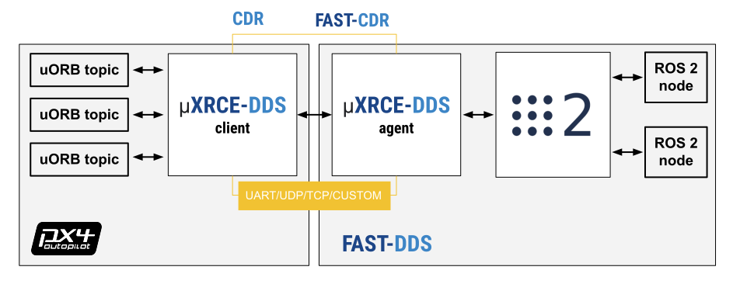Figure 3: Flight controller on the left and companion pc on the right

- For this particulat usecase a custom firmware was build to access particular informations like land detection, battery status.

2.3 Commander
The commander computer is the main computer from where the drone is controlled, it’s role is to run the following software:

2.3.1 px4-py.py
(also known as controller from her on) the main process of the system, sends heartbeat signals to the companion to keep it alive, recives updates on position, velocity, status etc. from the companion, recieves data from the GUI, and most importantly elaborates all the data and messages to produce an action to send to the drone.
This process is based on callbacks when a new message is detected, the main class OffboardControl(Node) keeps a record of the lates recieved.
If there is no GUI (set in config.py), it procedes with the selected mode in the configuration file, otherwise it listens for action messages.
Some actions are simply redirected to the companion (like arm, disarm, shutdown), other action that continue over time start a thread that compute and published mesasges to the companion over time and is stopped if a different a different command is sent.
The conrtoller is the only one who sends commands to the companion.
This this design the main thread constantly updates his own varables based on the lates message published by the companion, while every action over time is his own thread that based on the current status of the drone and can be stopped in any moment.

2.3.2 gui.py
- This graphical interface is a quality of life tool that considerably speeds up testing and validation since it makes possible to interface (in a human mode) with the controller, enabling runtime changes to the operating mode without editing and restarting the whole system.
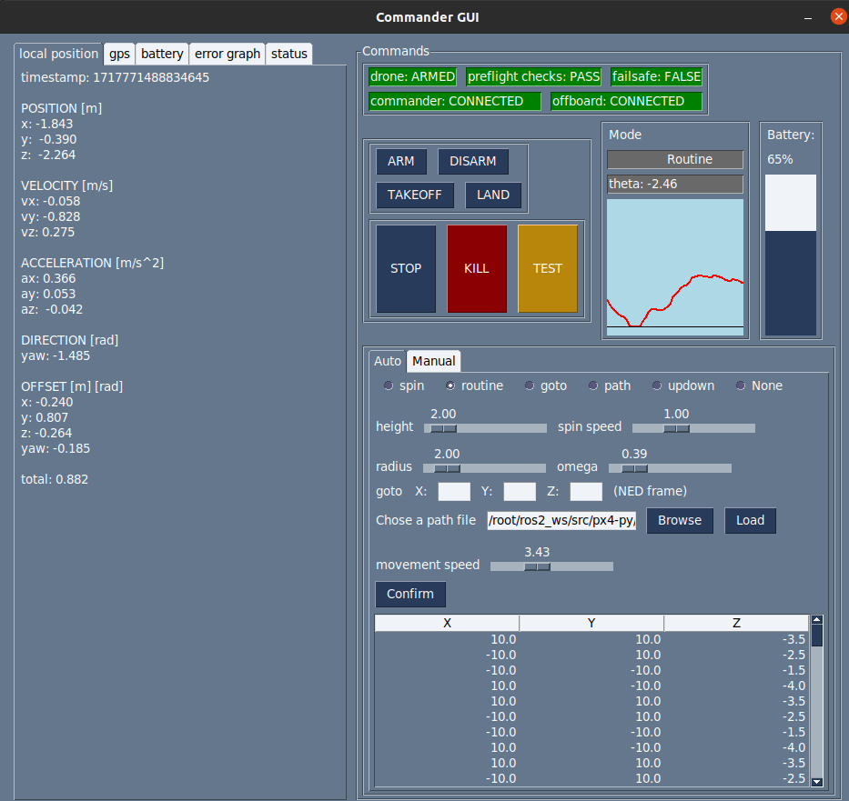Figure 4: gui.py

It has many functionalities and offers all the relevant information on screen:
- ARM arms the drone if the above contitions are met
- DISARM disarms the drone before it takes off or when it landed, does not work mid flight
- TAKEOFF takes of to the height declared in src/config.py by the variable takeoff_height
- LAND lands at (0,0) local frame, position cannot be overriden, this is a limitation of the offboard mode because it would require a different mode to land normally on locaton, disconnecting from the commander
- STOP stops any activity and hold the position
- TEST button to test features, currently lands on a random position
- KILL emergency stop, terminates the flight immediately and stops the propellers, even mid air USE WITH CAUTION
- SPIN spin on self with omega = spin speed slider
- ROUTINE starts hovering in circle around (0,0), at height = height , omega = omega slider,radius = radius
- GOTO goes to position x,y,z in NED frame (CAUTION WITH Z COORDINATES)
- PATH load a path file like src/medium.json and the drone fill follow all points with speed = moviment speed slider
- UPDOWN goes up and lands, mainly for testing
- NONE default, no activity, the drone will hover
- GRAPH shows arudimentary graph of position offset between the set position and the current position, gives a rough estimate of the offset
other commands and tabs are self explanatory
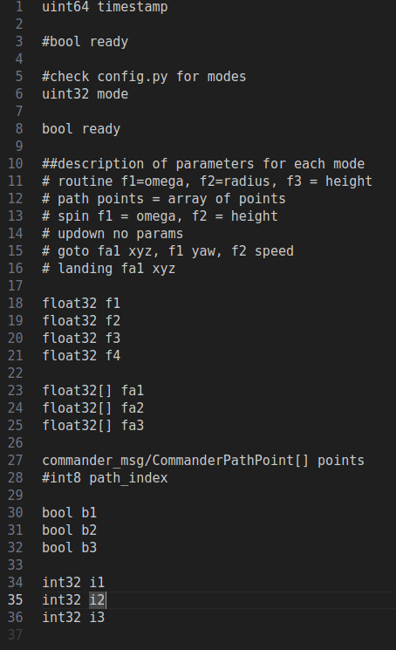Figure 5: Comamnder message structure for mode selection

The gui and the controller comunicate with custom Commander messages made by me, the style is similar to the original PX4 messages with an integer defining the mode and a series of arrays where to pass thee data, it’s upto the reciver to correctly parsing the meaning

This program is independent and the whole system can work without this piece of software since it doesn’t comunicate directly with the companion but only to the commander, this is a design choice to improve compatibility and automation.
Every information is accessible with the command line or a program with a ROS2 interface and every action is applicable with a script

2.4 Tracking
The tracking component is needed for indoor flight and is expected by default, GPS flight need a change in the parameters of the flight controller.
As previously mentioned the tracking system used for this project is the OptiTrack as it offers a sub-centimeter precision when correctly calibrated, but any other tracking device can be used as long as it can publish ROS pose messages directly or indirectly works.
The software needed to run the tracking system are:

2.4.1 Motive
- The proprietary software that is physically attached to the cameras, it published multicast messages int he network, must be configured with the shape of the tracker used.
- Must be interfaced witha client to access the date published.

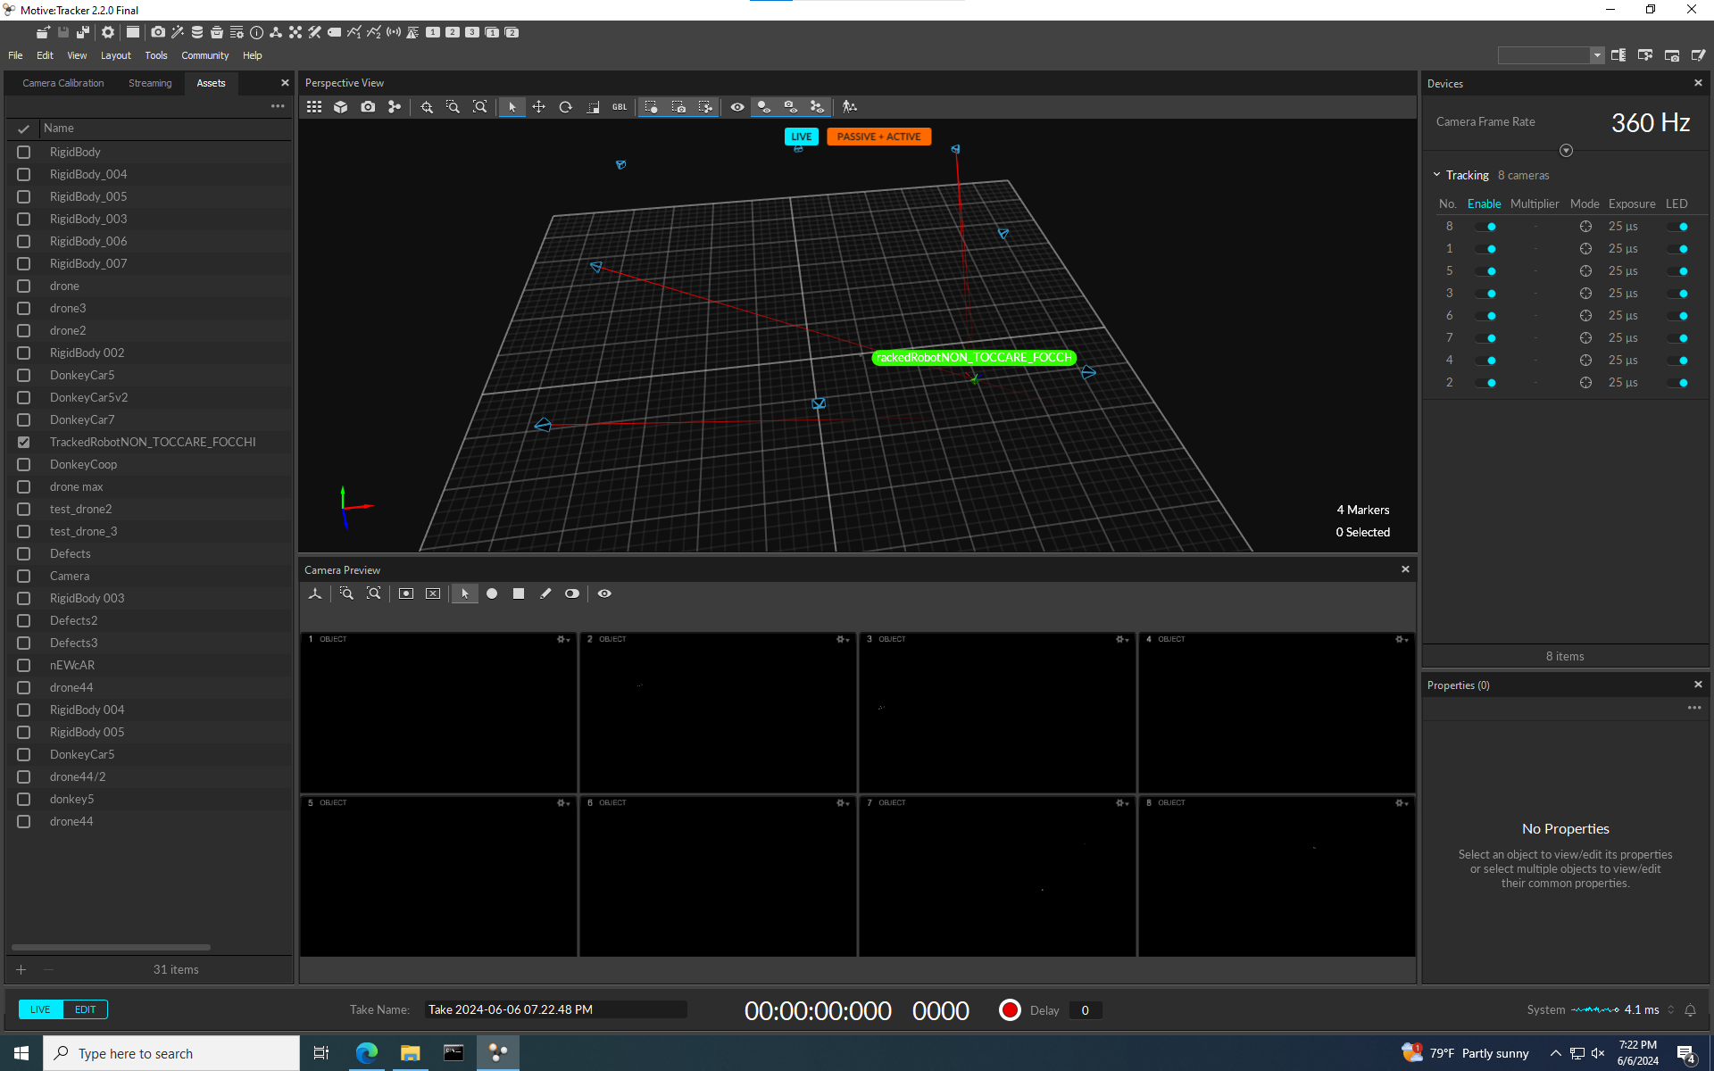Figure 6: Motive software

2.4.2 optitrack_interface
- python nat net client, it decodes the OptiTrack messages and publishes geometry_msgs.PoseStamped, a standard ROS message that can be accessed from the other programs.
- It’s confgured with the ID of the tracking device registered in Motive to avoid publishing messages from a wrongly detected body.

2.4.3 opti-to-px4.py
Python program listens to the OptiTrack messages and converts geometry_msgs.PoseStamped to VehicleOdometry messages, a PX4 message type and throttles the output to s stable 100Hz

- WHY?
- Why doing all these conversion of messages?
- Let’s procede with steps: the first conversion from Motive to optitrack_interface is need because Motive is a general pourpose trackign system and publishes it’s own format and not designed to work out of the with ROS2 so this step is unavoidable.
- But in the second part from optitrack_interface to PX4 we convert ROS2 message to ROS2 message, can’t we just skip the middle part and do Motive-PX4?
- The answer is yes, but not always.
- Let me explain, this setup was done in an existing laboratory and a standard PoseStamped is recognized by any ROS2 program and is the most suitable for the data transferred, so an existing setup might alerady have this system setup.
- So a PoseStamped message is more likely to be supported by existing setups and it’s more easily replicable and faked for testing purposes.
- In any case I developed an all in one solution for a direct Motive-PX4 and it’s called opti-to-px4-v2.py

This is all the software that is used to make the drone fly which is either proprietary software, forked and modified code or developed from scratch by me, all details are in the main repository.
- More programs are used in the simulation section but it’s not directly needed for the drone to fly.

3 Simulation
Flying simulations offer numerous advantages, the most important is being able to test new code in a safe virtual environment, there are zero consequences for a crash; meanwhile flying a real drone in a close environment while testing functionalities is definitely a recipe for disaster.
The simulator used is Gazebo

3.1 Gazebo
Gazebo is a collection of open source software libraries designed to simplify development of high-performance applications.

It’s widely used in robotics because it supports many plugins that can be developed for each system, it’s very modular and offers a fine customization.
Gazebo supports the SITL drone simulation that was needed directly from the PX4 package.
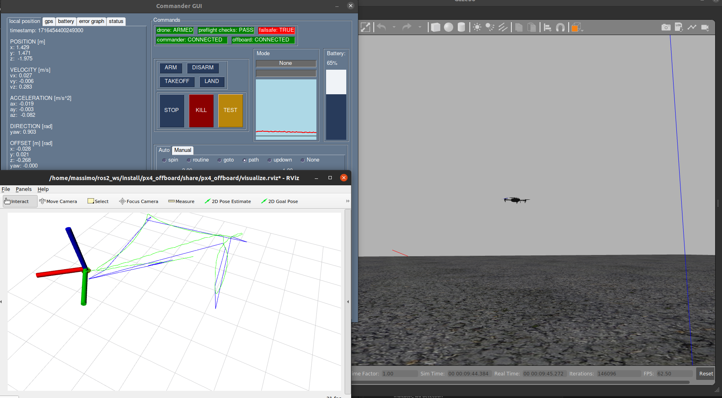Figure 7: Fully functional drone simulation. Gui on top left, RVIZ in bottom left and Gazebo on the right

3.2 RVIZ
- RVIZ is another program usually paired with Gazebo, it doesn’t directly simulate but allows the user to visualize ROS messages in a very convenient way.
- While the front end displays the evolution of the system, the backend is a fork of an existing project, properly changed to receive PX4 messages, organizes a history of messages and set, converts the coordinates from NED and FRD frames to ENU and FLU, the former are commonly used with flying vehicles where the Z axis represents the negative distance from the ground while the latter are the common coordinaets; this step is done for visualization purposes, every aspect of the flying drone is done in NED and FRD frames.
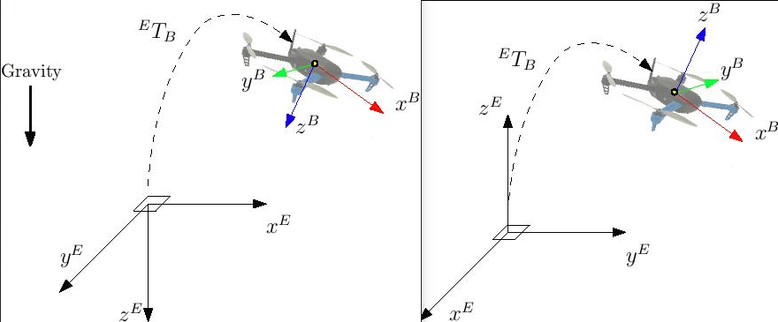Figure 8: coordinate convertion

4 Flying
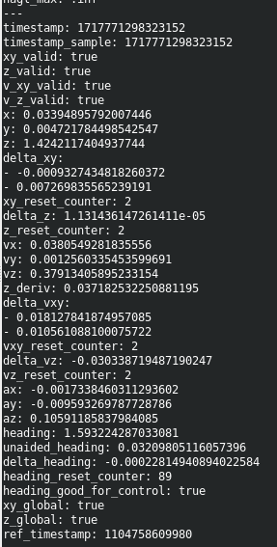Figure 9: raw local position message from PX4
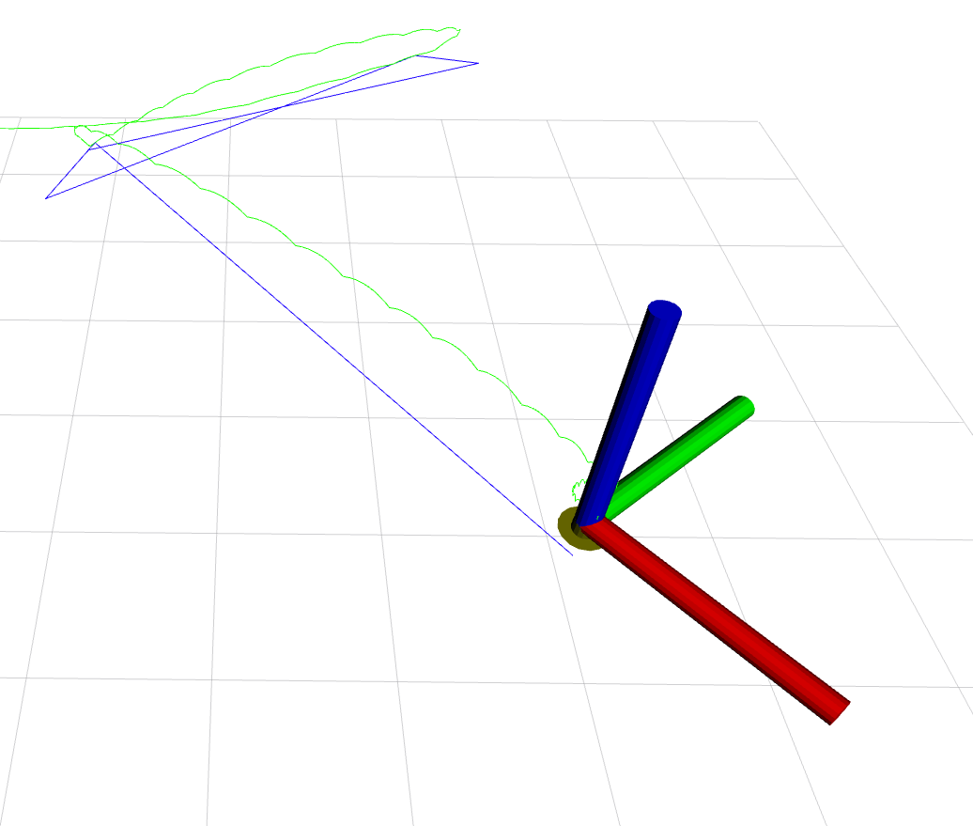Figure 10: RVIZ scree, the blue line is the theoretical path, the green line is the real path taken
Now that we know what each component does I will explain the whole procedure to launch the drone and the connections between all the software:
- Start Motive and the OptiTrack system.
- From the companion MicroXRCEAgent to interface the flight controller with ROS.
- From the companion launch optitrack_interface and px4-py.py to connect the drone with the optitrack.
- From the companion launch the controller px4-py.py
- (optionally) launch the gui.py
- set the action through gui or ROS2 message

Bibliography

#todo

